SYNOPSIS
MAJOR PROJECT
ON
Blockchain Voting App

Submitted by
Vipin Kumar Dinkar
03916404517

Under the supervision of

Dr. M. Bala Krishnan
Associate Professor

in partial fulfilment of the requirement for the award of degree of

MASTER OF COMPUTER APPLICATION
IN
SOFTWARE ENGINEERING


University School of Information, Communication & Technology,
Guru Gobind Singh Indraprastha University, New Delhi.
Jan-May, 2020

Table of Contents

1. Abstract 3

2. Introduction 3

3. Problem Statement 4

4. Objective 4

5. References 4

Abstract

We live in a country where we have democracy that’s why we have a voting right. We can choose any candidate of our choice. In India we use EVM (Electronic Voting Machine) [4]
In place of paper. We thought that digitalising the process of voting will help us in removing corruption and fraudulent activities and we were in a impression that it happened.
But in a demo [3] by APP (Aam Admi Party) in 2017 assembly, showed us that we are wrong. Evm are easily hackable hence, our voting right is used wrongly.
Here comes a new era of Decentralised networks, Cryptocurrency which ensures that no transaction can be hacked or modified since it goes thought all the nodes for verification.
So why don’t we use it as it provides security as the hash will require tremendous amount of time before we can manipulate it.

Introduction

Blockchain

The blockchain is a like a immutable linked list which records every transaction happens.
The blocks are added to blockchain in a sequential and linear . The blockchain network have all the information from the origin(genesis ) block to the latest block and can traverse easily without any cost.The reads on the blockchain are free but writes cost(GAS)[2]
Every Block is immutable so when a block is generated it cant be modified.

Ethereum

Ethereum is a global, open-source platform for decentralized applications.
On Ethereum, you can write code that controls digital value, runs exactly as programmed, and is accessible anywhere in the world.[1]

Smart Contracts

It is an auto executing piece of code or contract which functions only when certain conditions are met. It lives in the middleware of every blockchain.

Problem Statement

All the existing voting systems lack security, transparency and efficiency. When we vote for a candidate we don’t know if our vote is casted to him or not. Also, humans have a tendency to do bad things under pressure of money, power and greed. We need a fool proof system which provides us a guarantee and cost less than the previous one as the Evms needs maintenance and regular security check-up and transportation and storage cost .

Flow Chart
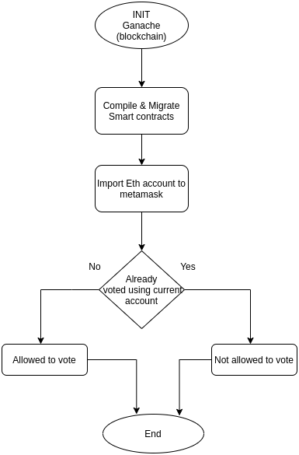

Objective

This project will solve the problem of security and fix any fraudulent activity. Blockchain is paving the way for a direct democracy. The rules of political parties and the elections needs to be changed so that they can be transparent and support blockchain environment.
We can show super-fast results after elections are done since all the blocks are connected, we can run query and visualize the data and find the winning candidate within minutes or even seconds. This app will gain confidence as everything is transparent and immutable after being created (vote casted). This app will cost less than the traditional EVM [4] and the cost of the people for security and transport. It is the true digital version of the voting process.

Hardware and Software Requirements

HARDWARE REQUIREMENT:
1. RAM: 2GB or more
2. Processor: 1.2 GHz or Higher Processor
3. Storage: 100GB or more live free space on server
4. Screen resolution: minimum 1024x768
5. Sound Peripheral: headphones, speakers
6. Internet: 512kbps min

SOFTWARE REQUIREMENT:
1. Web Browser : Chrome , Firefox ,Safari
2. MetaMask : Extension to convert browser into blockchain browser
3. Truffle.js : A opensource blockchain framework for Ethereum based network
4. Web3.js : It is a collection of lib which allow you to interact with local or remote ethereum node using HTTP or IPC
5. Node : An open-source, cross-platform, JavaScript runtime environment that executes JavaScript code outside of a browser
6. Ganache : One click blockchain (Local) tool which also generates accounts with fake Ether
7. Code Editor : Vs code ,Sublime ,Atom etc.
8. jQuery : A fast, small and feature rich JS library.

Simulation

ScreenShots

References

- https://ethereum.org/
- Blockchain: Blueprint for a new economy (February 2015) ISBN : 978-1-491-92049-7
- https://www.youtube.com/watch?v=32F3X1E121A
- https://eci.gov.in/evm/

